Computer Networks Lab – Week 10

PES1UG19CS592

Yashi Chawla

1. **IPv6 Address and Topology Creation**

The following topology was created and deployed on Claynet

Alice and Bob are the two workstations for this experiment.

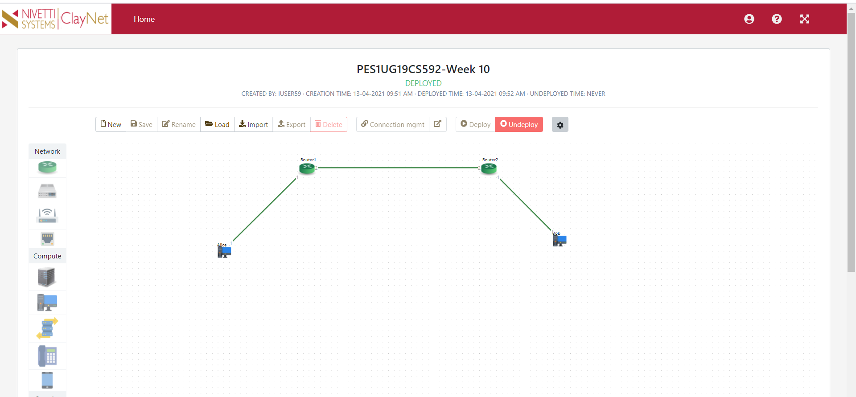

1. **Configuring IP address for end systems**

The end systems are configured as

|  |  |  |
| --- | --- | --- |
| End system name | IP address | Gateway |
| Alice | 2001::02/64 | 2001::01 |
| Bob | 2003::02/64 | 2003::01 |

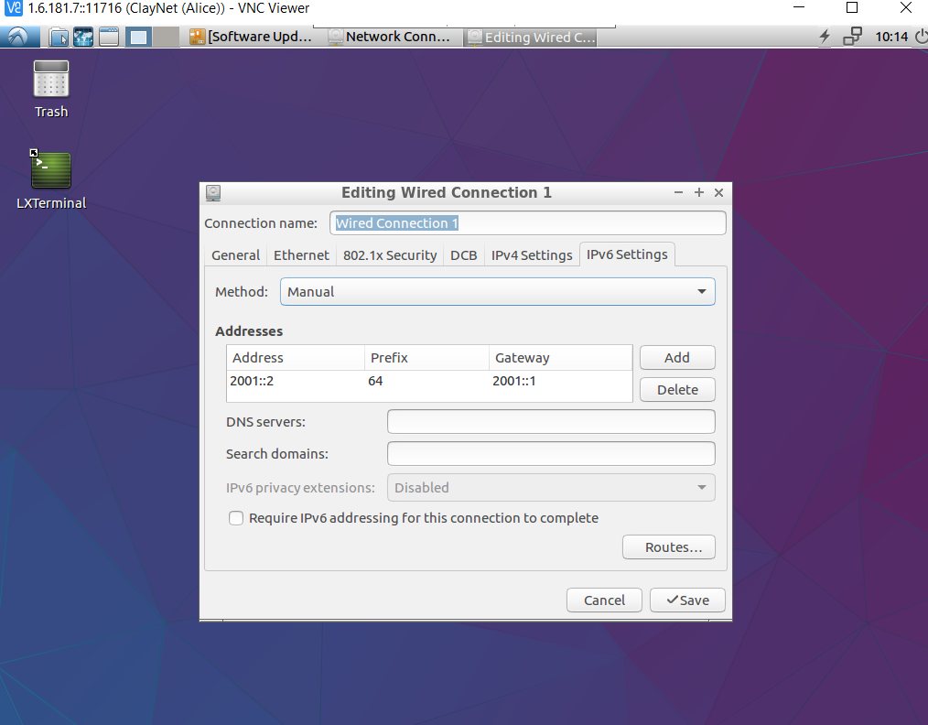

Alice

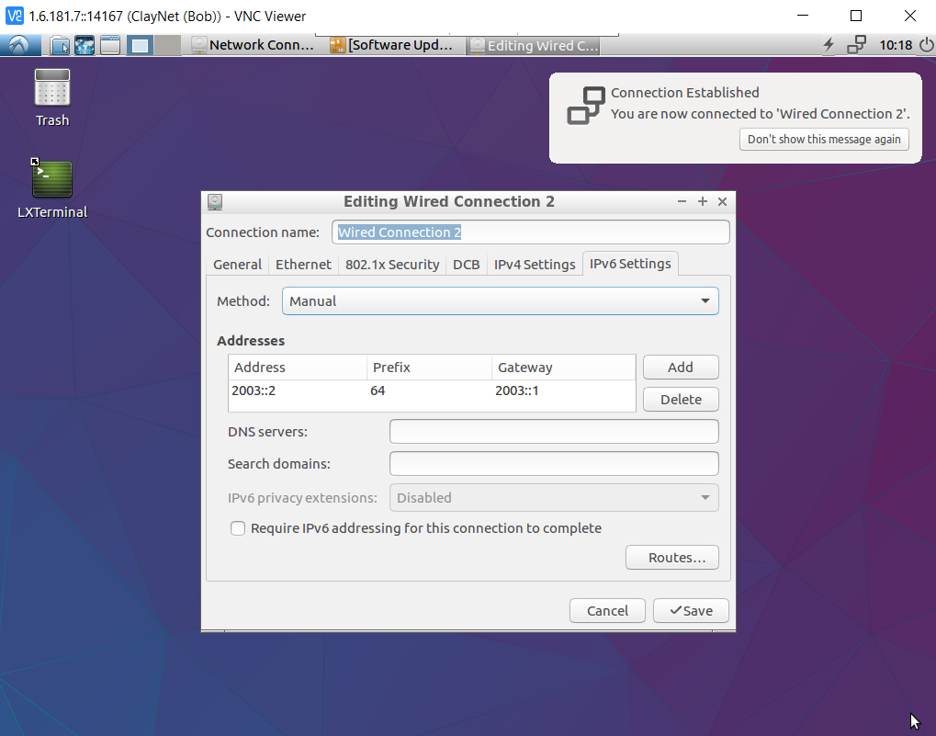

Bob

1. **Router 1 Configuration**

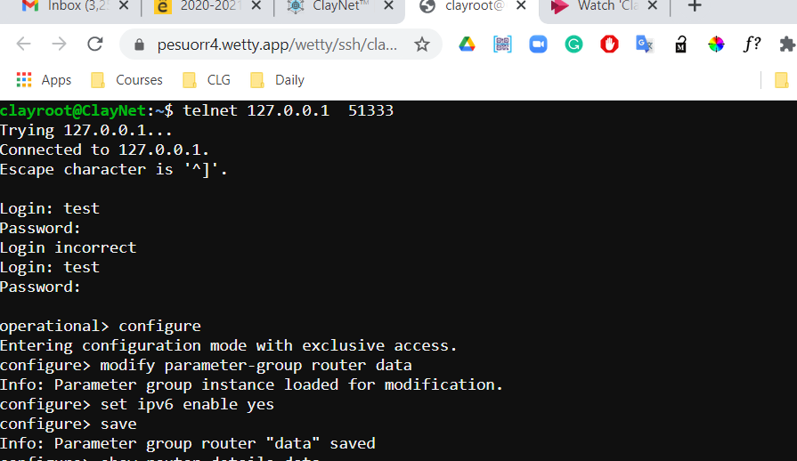

Enabling IPv6 mode

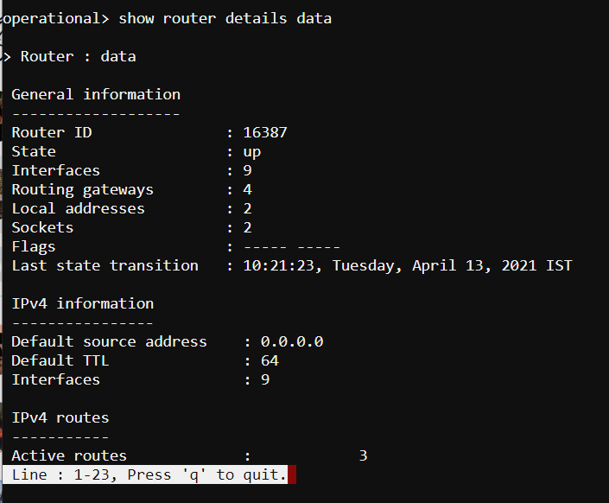

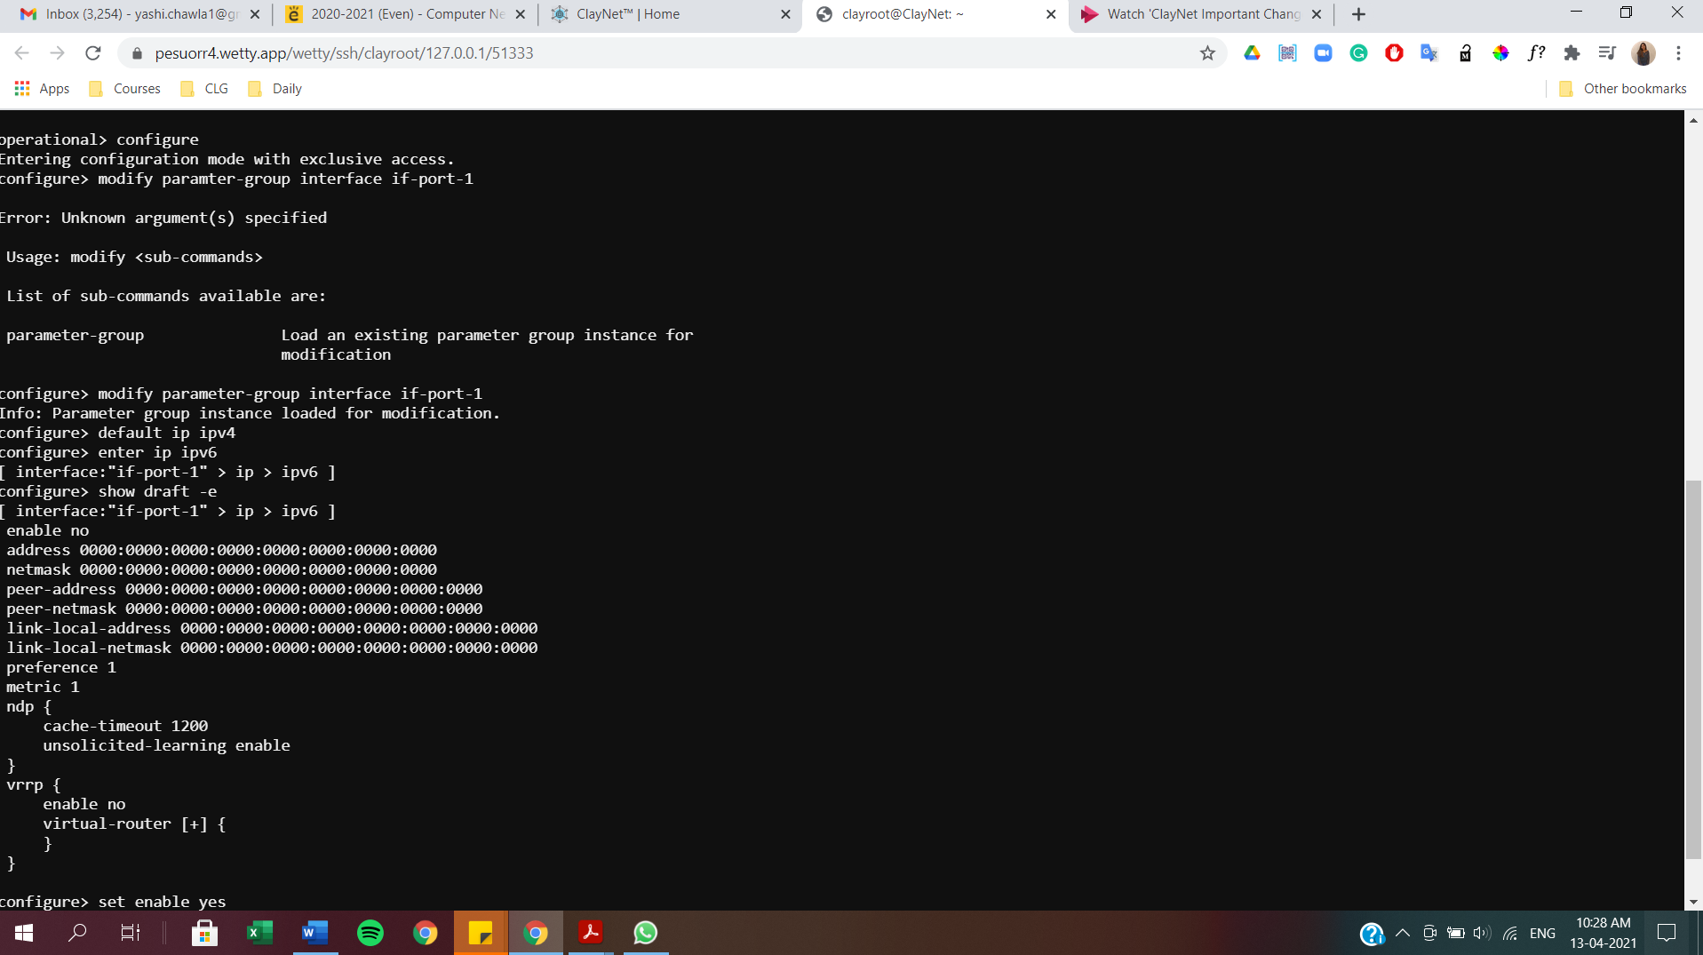

Assigning IPv6 Address 2001::01/64 to the if-port-1 interface

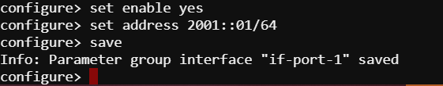

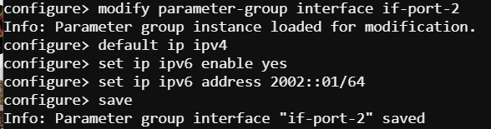

Assigning IPv6 address of 2002::01/64 for the if-port-2 interface

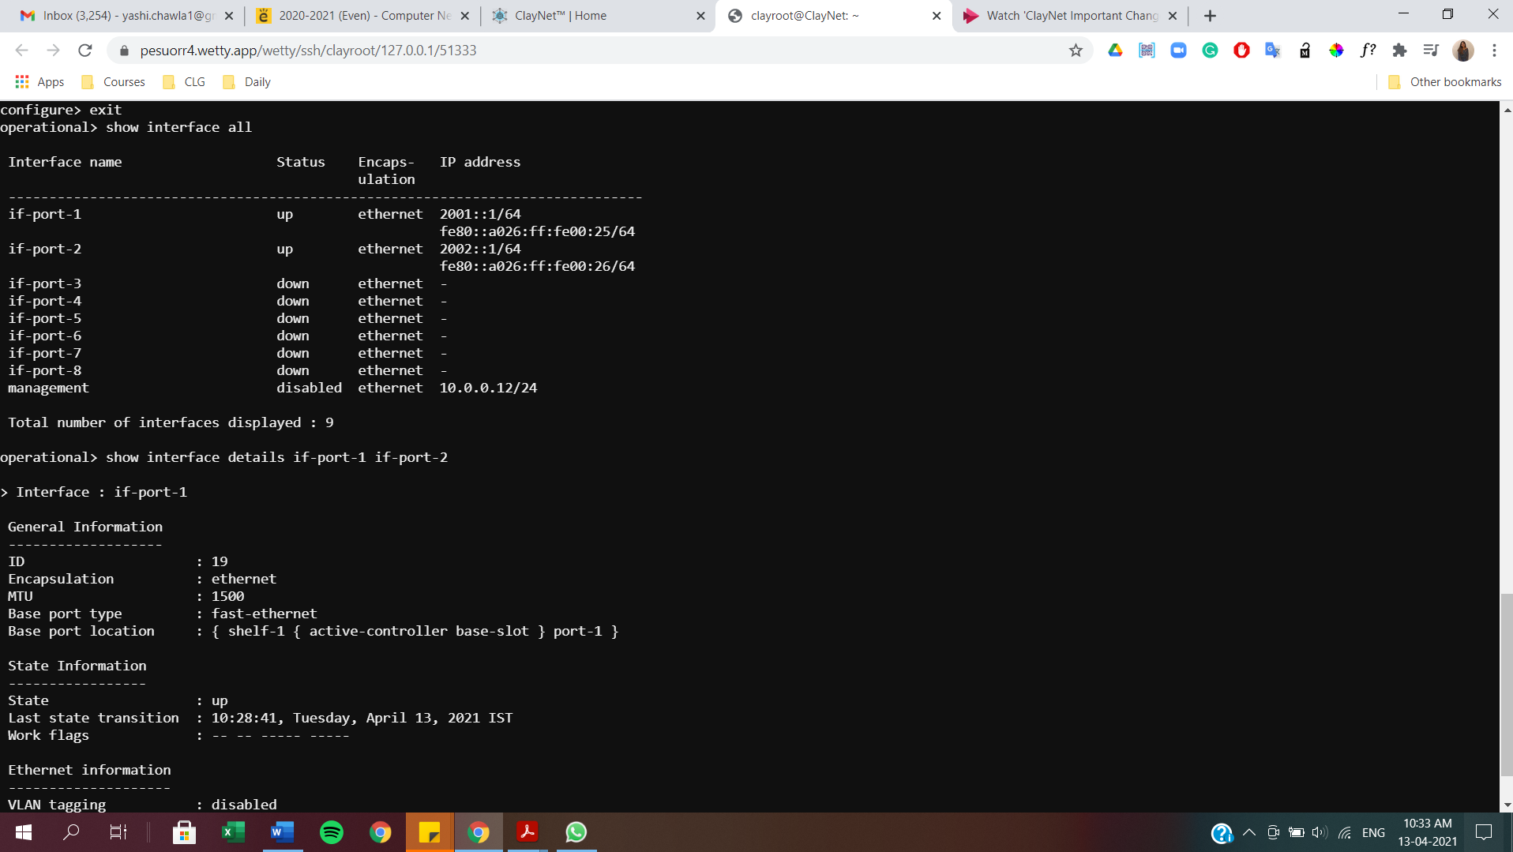

Full interface configuration

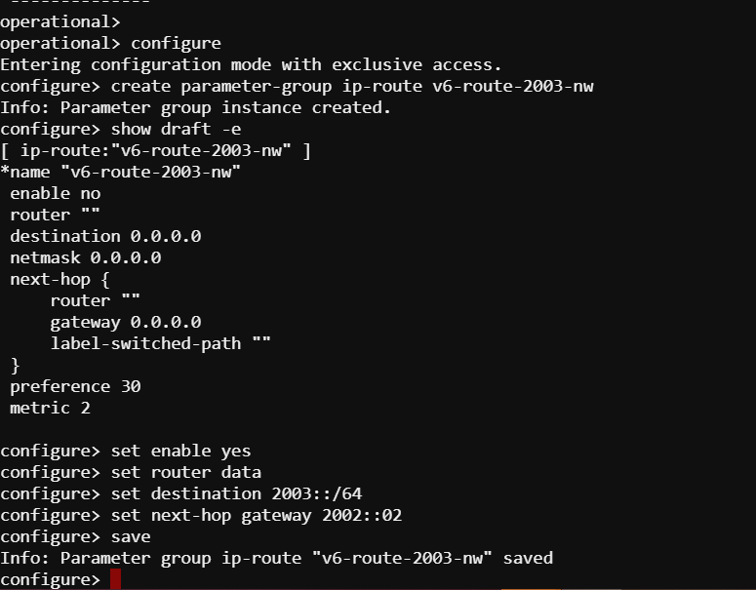

Configuring a static route to reach 2003::00/64 network(Bob) with gateway as 2002::02(Router 2)

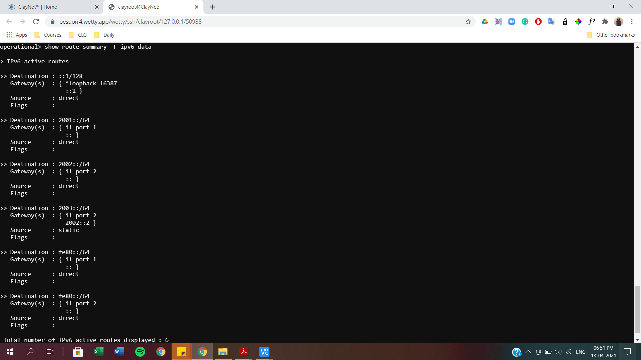

Routing table entries as seen above

1. **Router 2 configuration**

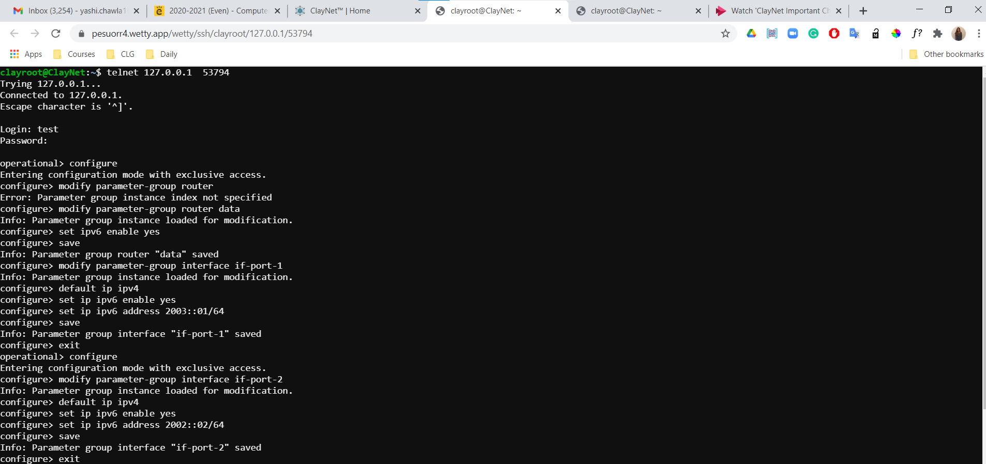

Assigning IPv6 address 2003::01/64 to interface if-port-1 and 2002::02/64 to interface if-port-2

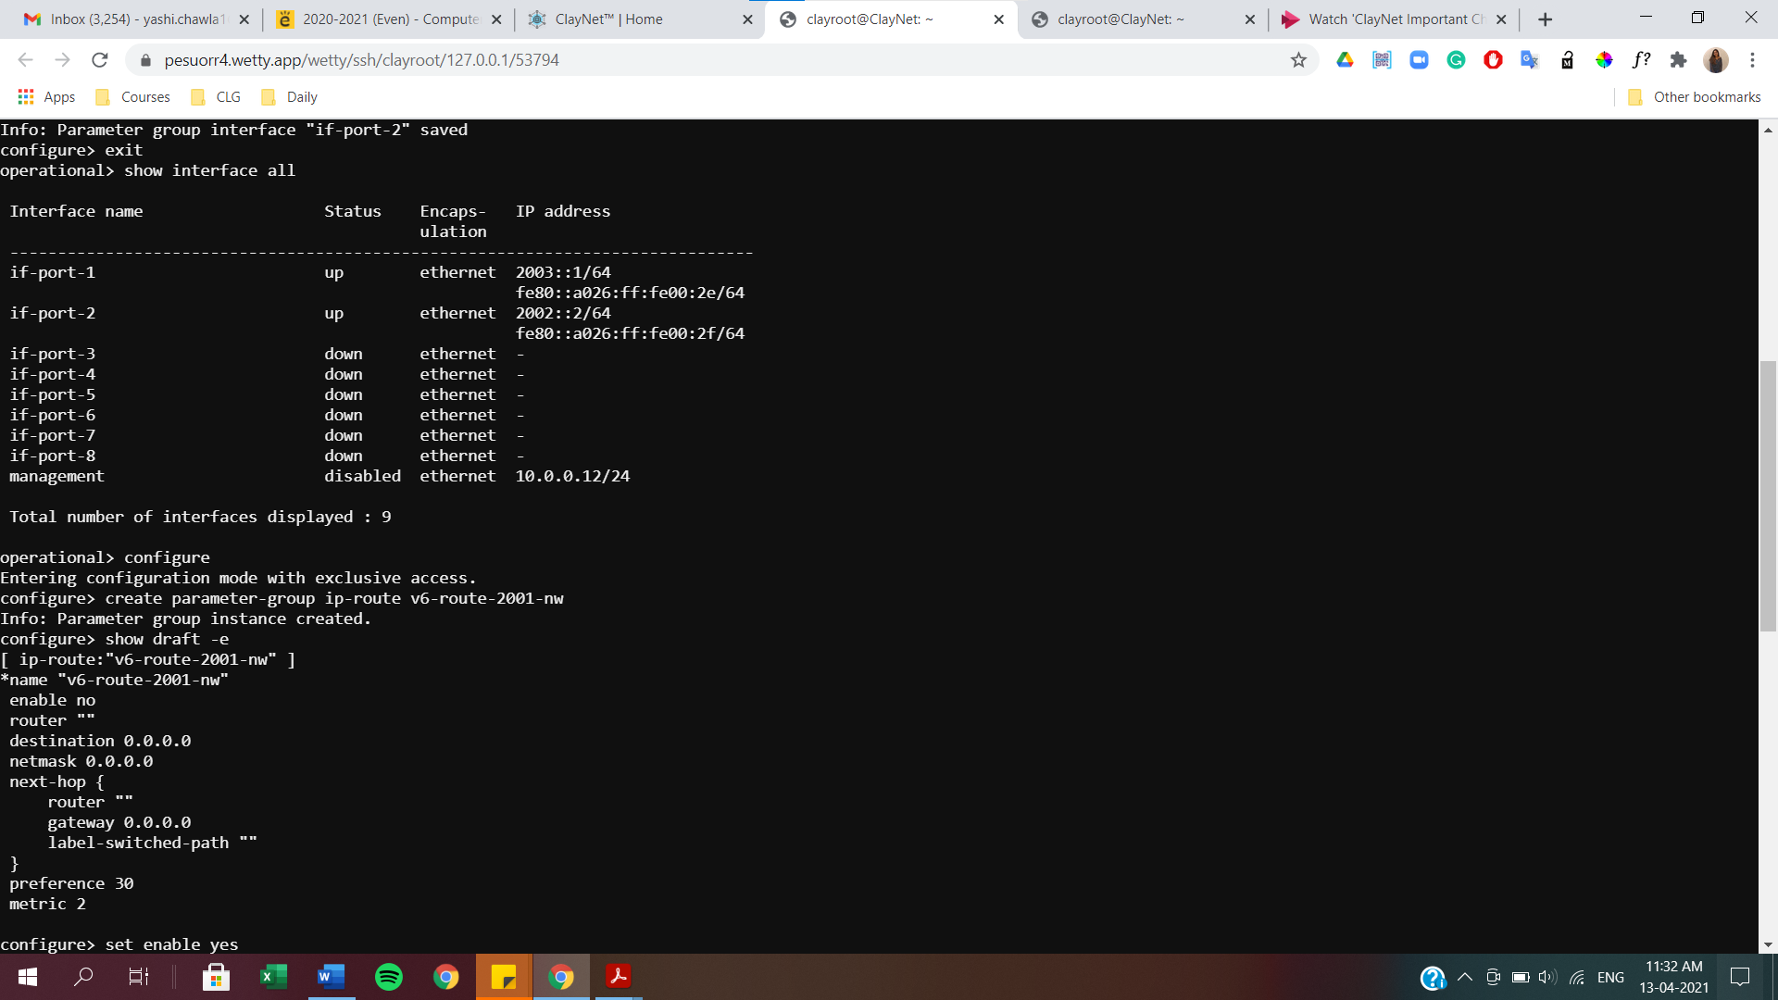

Static route to reach 2001::00/64 network(Alice) with gateway as 2002::01(Router-1)

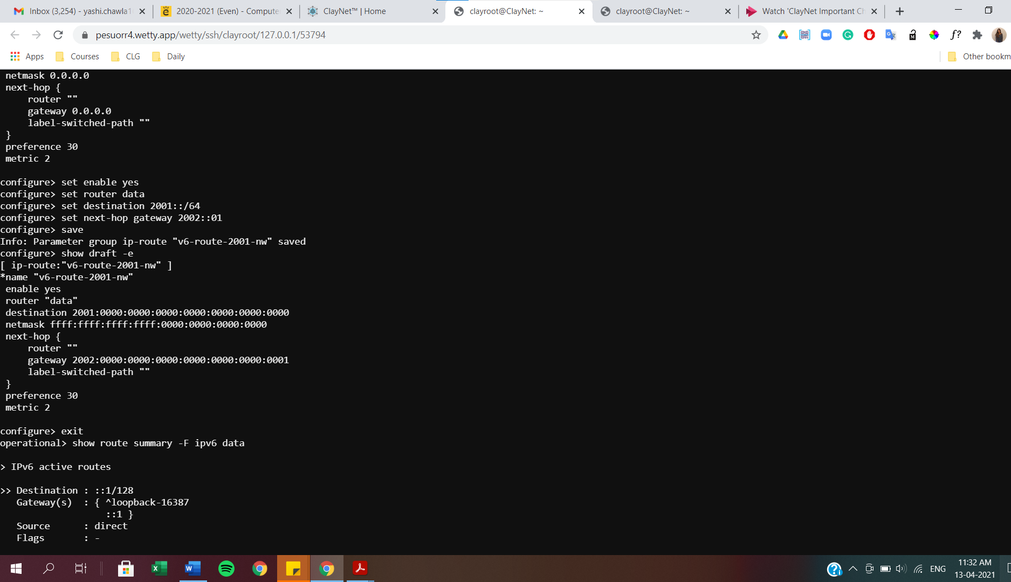

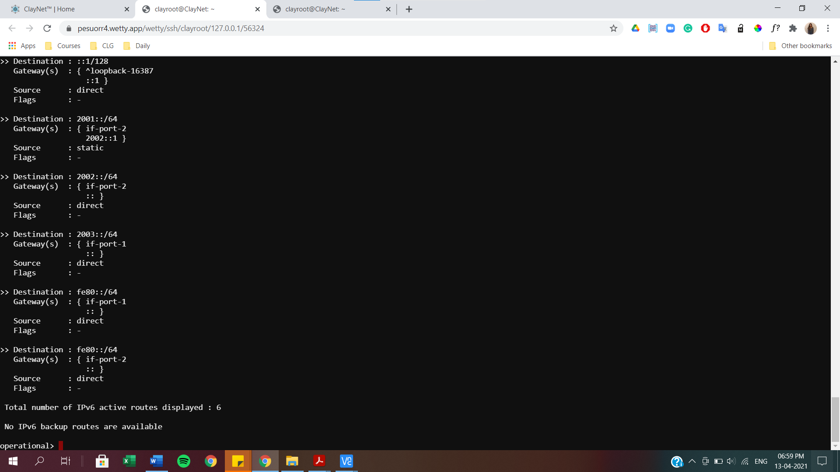

Final routing table

1. **Ping Command and Tracepath**

Successful ping requests can be sent from Alice to Bob workstations as shown below.

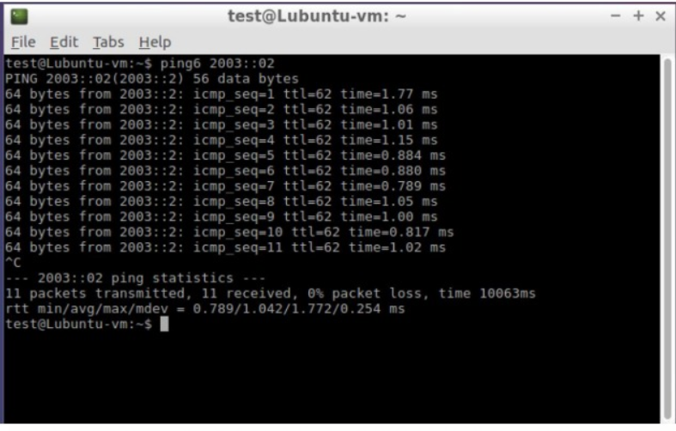

Similarly for tracepath

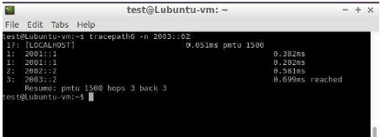

**6. NDP table on Router -1**

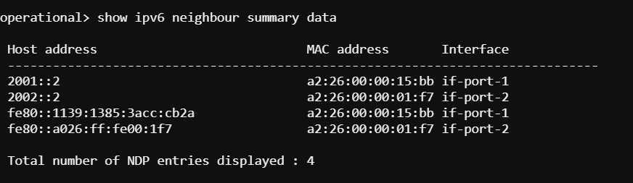

7. **Verifying auto configured link local address on IPv6 interfaces**

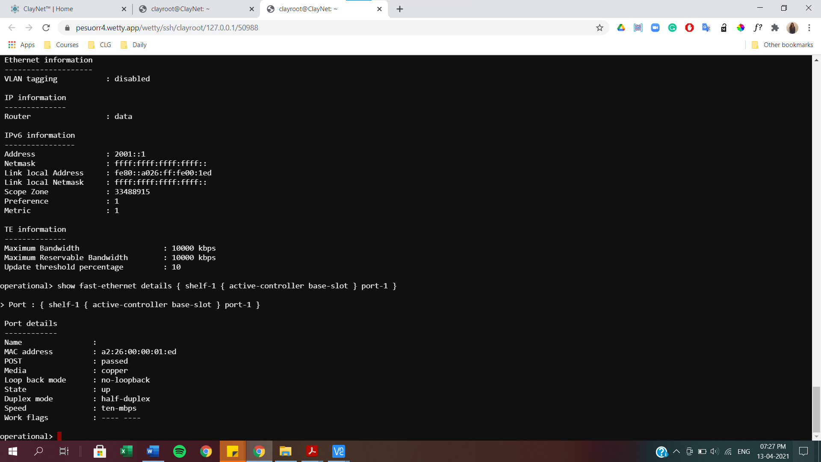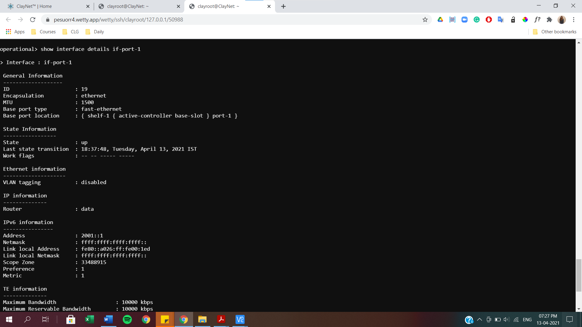

**8. Checking connectivity between Router-1 and Router-2 using link local address**

